University of North Carolina Asheville

Journal of Undergraduate Research

Asheville, North Carolina

Spring 2025

A Title that is Informative and Descriptive

[DO NOT include your first and last name on initial submission for blinded review - only include your Student ID Number! All manuscripts should be submitted as .doc or .docx files – no .pdf, .rtf, or other file formats. High resolution images can be uploaded separately as .jpg/.jpeg or .png files.

For your final submission, please include your first and last name instead of your ID number. Please ensure you save your document with the following required file naming convention - LAST NAME, FIRST NAME - FINAL Fall 2025 Journal Submission (replacing ‘Fall 2025’ with the relevant term. Delete this text before submission.]

Student ID

Department/Program

The University of North Carolina Asheville

One University Heights

Asheville, North Carolina 28804 USA

Faculty Mentor:

Abstract

This template document has been carefully formatted to make manuscript preparation easy, to ensure consistency among submissions, and to be accessible to screen readers and other needs. Put your abstract here. It should be no more than 300 words and should give the reader a full idea of what the paper is about. This text should be of the type ‘Normal’, as defined in this document (Arial 12 pt font). Questions should be sent to [studentresearch@unca.edu](mailto:studentresearch@unca.edu) with subject line “Journal Question”.

# Section 1

This section runs immediately after the Abstract text; do not create a page return. This text should be of the type ‘Normal’, as defined in this document (Aptos 11 pt font). Note how this and all other ‘Normal’ formatted text uses a 2/8 inch indentation on paragraphs, as specified in the ruler at the top of the document. Retain this indentation format for all paragraphs.

# Section 2

In this section we discuss formatting guidelines that have been updated in 2023 to follow standard accessibility guidelines. Section headings should be in the Heading 1 style, as defined in this document.

## Subsection 1

Subsection headings should be in the Heading 2 style, as defined in this document. This section should be in prose, not bullet points, but please follow the list of style requirements in the list below.

* Use this template!
* Make a copy of this document and paste your text into this it to make use of its formatting.
* Ensure the semester and year are correct in the headers on page 1 and on page 2 (all subsequent pages match page 2).
* New headings and subheading should be formatted using the style guide at the top, or by copying and pasting new section titles where you need them. Using standard styles makes the document more accessible for those with reading disabilities/blindness using screen reading tools. Click on the Styles Pane button in the Home menu, above, to get easy access to the different styles.
* Ultimately, the body of your paper should be in Aptos 12-point font (Normal), 20 point font for section titles (Heading 1), 16 point font for subsection titles (Heading 2). There are distinct Styles for the First Page Header, Byline and Department, Abstract heading, and Figure/Table captions.
* [This page from the OAA](https://accessibility.unca.edu/for-faculty-staff/course-accessibility-checker/) gives additional accessibility guidelines.
* No minimum page length, maximum 25 pages
* Single spaced body of the paper, one-inch margins
* First page header only goes on the first page (not every page)
* Use citation guidelines consistent with your discipline.
* Papers may be written in LaTex.

## Subsection 2

Published papers will reflect original student research and creative activity. Papers should follow the guidelines for content presentation that is standard in your discipline. This may or may not include headings, tables, figures, and graphs. This journal supports papers from all disciplines that reflect original work of the student author(s). Examples include (but not limited to) literary analysis, scientific field or lab research, creative writing, historical analysis, linguistic analysis, and mathematical proofs.

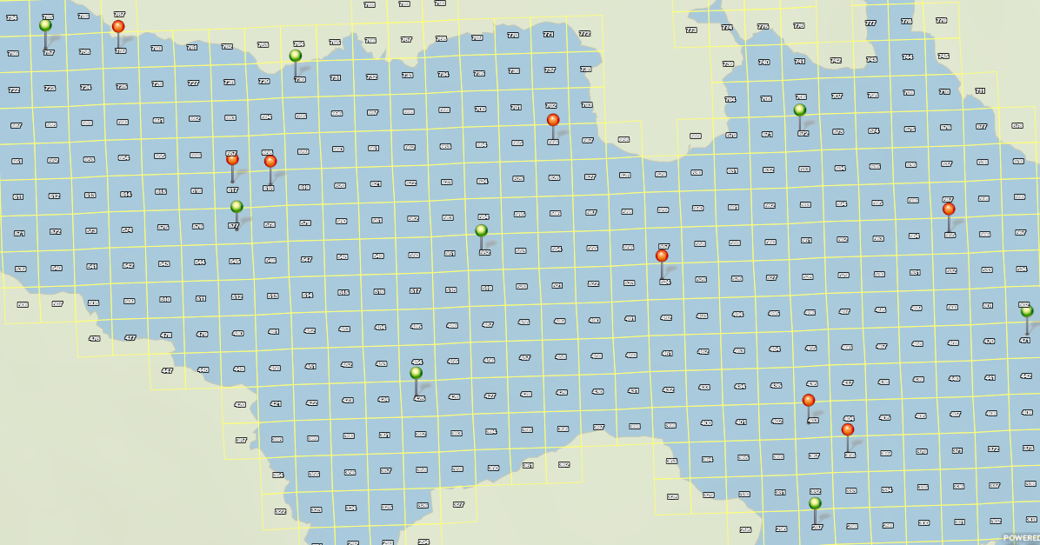

**Figure 1.** Label Figures and Tables with descriptive captions such that the image and caption could be seen outside of the context of the paper and still make sense or be read by a screen reader and properly described to someone unable to see it. Figures, tables, and graphs should be centered on the page.

# Section 3

In a scientific paper, sections 1-3 might be the Introduction, Methods, and Results. Discuss an appropriate structure for your paper with your research mentor. It is not necessary to have subsections, but they may help with the organization of your ideas and your manuscript.

# Acknowledgments

It is appropriate to thank any faculty, staff, or community members that supported the completion of the project or manuscript. It is standard to acknowledge any organization that provided grant money for the research, citing grant names and numbers if applicable. If you received research funding from the Undergraduate Research and Creative Activity Program, the McCullough Fellows program, or another UNCA program, acknowledge it here.

# References

Use the reference system that is standard in your discipline, or APA if there is no standard in your discipline.